8 June 2020
AP Literature 2020-2021 Letter of Introduction to the Course
and the Summer Assignment
CONGRATULATIONS! YOU ARE REGISTERED AS A MEMBER OF THE
AP ENGLISH LIT & COMP--CLASS OF 2021!

Greetings! I am writing this letter because you have registered for Advanced Placement Literature 12 program. This letter is my official welcome to the course, an overview of my philosophy, and your outside of class novel reading assignment. Please read all documents regarding the class so that you have a CLEAR understanding of what this class entails.

ABOUT AP ENGLISH LITERATURE. AP English Literature & Composition is a semester long course offered each semester.

A RIGOROUS COURSE: AP English Literature & Composition is a rigorous program designed for the high-achieving, highly-motivated college-bound student. You can expect a course that will challenge you and reward your efforts. You must have mastery of writing essays, confidence in analyzing literature, commitment to hard work, and a strong desire to participate fully in a discussion-based class. AP Literature & Composition is not a foundational class. The basics of English grammar, punctuation, and organization of an essay are prerequisites. In addition, a dedication to stretching yourself creatively is highly desired.

My experience with AP English Literature & Composition exams over the years has shown that Eden Prairie students need, quite frankly, to read more literature from what is known as the "canon" (those established works considered by many to be the "great literature" of the ages). Moreover, serious students simply need to spend more time reading. Becoming more widely read in great literature is one of the best ways to expand your vocabulary as well. You will also widen your view of the world through the vicarious experiences you receive from literature. Furthermore, you will enhance your critical skills and develop your own response to and appreciation of literature.

AP 12 WORDPRESS WEBSITE:

Here is the URL for the AP HOME PAGE https://wallenbergsplit1.wordpress.com/ (1st sem.) or
https://wallenbergsplit2.wordpress.com/2016/01/25/frankenstein-lesson-plans-and-hw-2013/ (2nd sem.).

NOTE: We may be switching over to Schoology, as we had to last year because of distance learning, but you can check out the Wordpress site for now to find many valuable materials for class.

Thank you for your interest in this challenging and rewarding educational experience. If you have any further questions, email me. I look forward to seeing you next year!

Sincerely,

Wally

Linda Wallenberg (email Lwallenberg@edenpr.org)
Eden Prairie High School AP English 12 Instructor

Advanced Placement English 12: Literature & Composition Syllabus
NOTE: This course requires “summer reading.” You are required to read the following novels, actively read the text, and do extensive note-taking. You will be given an AP exam on some of these books the first week of class as well as evaluated on the quality of your active reading and note-taking.
1. A Prayer for Owen Meany by John Irving
2. Tale of Two Cities by Charles Dickens
3. Pride and Prejudice by Jane Austen
I. Course texts
The following is a BANK of material from which the AP English 12 course content will be chosen.
- Literature: The British Tradition (published by Prentice Hall)
- English Writing and Skills (Complete Course, Coronado edition)
- Beowulf (translated by Seamus Heaney)
- Grendel by John Gardner
- Chaucer’s Canterbury Tales (translated by R. M. Lumiansky or Neville Coghill) by Geoffrey Chaucer
- Hamlet (Signet Classic edition) by William Shakespeare
- Rosencrantz and Guildenstern Are Dead by Tom Stoppard
- Things Fall Apart (Fawcett Crest edition) by Chinua Achebe
- Heart of Darkness (A Case Study in Contemporary Criticism Series edition) by Joseph Conrad
- Arcadia (Samuel French, Inc. edition) by Tom Stoppard

II. Course content
The following is a BANK of material from which the AP English 12 course content will be chosen.
- Course Introduction and Philosophy, Summer Reading, and Building a Class Foundation
- Familiarization with the AP Literature and Composition:
      - Phrases and clauses in composition
      - Rhetorical strategies
      - Practice exams
  - Cultural Literacy Tidbit research paper
- Poetry terminology and poems—including some classics from the 17th century (1625-1660) through the 20th century.
  - Literary Analysis paper (comparison of two novels)
- Anglo-Saxon and Medieval 450 AD – 1485)
    - Historical background
    - History of the English Language
    - Beowulf
    - Grendel
    - Chaucer’s Canterbury Tales
  - Evaluation paper: Literary Theories paper
- English Renaissance (1485 – 1625) Hamlet
- Modern reaction to Hamlet: Rosencrantz and Guildenstern Are Dead
- Joseph Conrad’s Heart of Darkness – analysis and criticism
- Chinua Achebe’s Things Fall Apart – analysis and criticism
  - Position paper
- Tom Stoppard’s Arcadia
  - Narrative paper based on Chaucer’s Canterbury Tales
- Course final: “Meeting of the Minds”

SUMMER READING and WRITING REQUIREMENT

DEADLINE: 2020 due date: Tuesday, September 1st, 2020
(regardless if your course runs first or second semester)

- Summer Reading Requirement: Read & annotate three novels.
- Complete Journal WA 1 Quote Pondering (2 sides minimum)
- Complete AP Literature Short Answer Questions

1. SUMMER READING REQUIREMENT: Read & annotate 3 novels.
“Actively read” and take “reading notes” on the following THREE novels. This work is due the first Friday of the first week of school next fall whether your course runs first or second semester. There will not be an exam on the novels, but the Literary Analysis Paper will be based on these novels, and we will continually reference them thematically throughout the course. The following are the three required novels for AP English 12:
- A Prayer for Owen Meany by John Irving
- Pride and Prejudice by Jane Austen
- Tale of Two Cities by Charles Dickens
You will need to purchase your own copies at a local bookstore so you can "actively read" the texts. You may choose any edition of these novels. Critical editions may be most helpful as they often have explanatory footnotes or endnotes.
Many college professors require evidence of "active reading" in texts. This means making personal notes in the margins of your books. So, you must actively read the THREE texts AND take separate reading notes which might include some or all of the following: recording questions, making connections, looking for symbols, tracking plot structure and character development, as well as identifying major themes. We have designed grading rubrics for this active reading which outline the specific requirements. Look on the following pages in this document to view these rubrics. Expect that your first AP practice essay exams will be based on the novels you read. Later in the term you will write a paper based on these texts, so it will be invaluable for you to have the active reading and reading notes to refresh your memory.
What is “Active Reading”?
The Goal of Active Reading: To own what you read. The objectives:
To have ideas and opinions about a reading;
To retrieve information quickly;
To organize information from the reading;
To increase comprehension, vocabulary, analytical and evaluation skills, links with what a reader already knows, long term memory;
To improve working knowledge of the literal aspects of a work;
To allow readers to deepen original ideas;
To help the reader inductively discover the meaning of a work and to have stated it in his own words;
To find the purpose the author had in writing the work;
To provide ideas and questions for class discussion;
To have a “conversation” with an author
To think as one reads

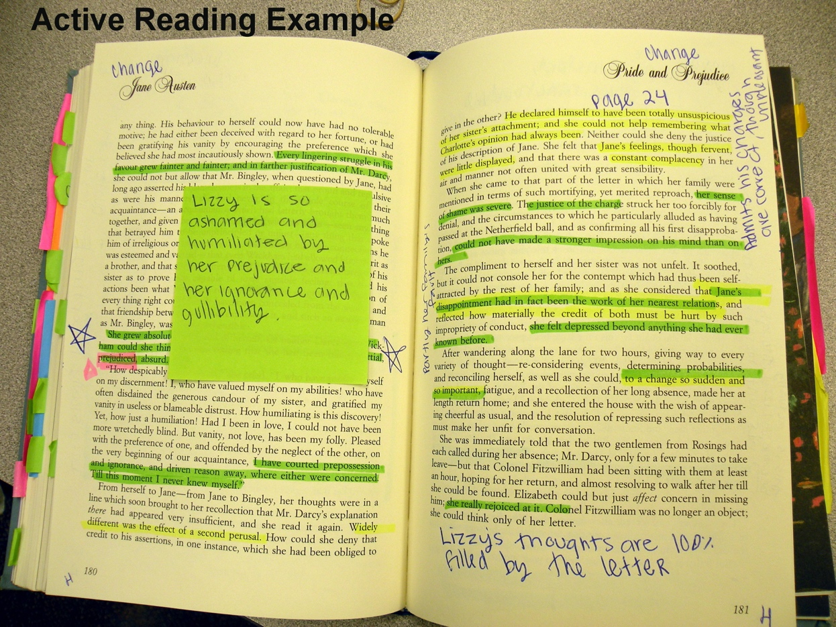

HERE’S HOW TO DO THIS “ACTIVE READING”:
Generally, for Active Reading of passages, highlight, box, star, code, translate, paraphrase, summarize over or beside lines, sentences, and passages. On pages, write notes in margins, on bottoms, tops, or in corners and/or add post it notes to accommodate reader’s notes. On end flaps, create titled lists and categories of information and collect information under these categories with quoted, key words from passages and the page number next to the quoted word (fuller notes should be made on the entire quote in the text itself)

HERE’S HOW (IN MORE DETAIL)
- Analyze, evaluate, speculate about the title before beginning to read and then come back to the title after reading and summarize its relevance – always write a sentence or so explaining its relevance to the theme or thesis of the story/article;
- Examine chapter or section titles or headings before, during, and after reading; Identify and comment on the narration – 1st or 3rd person, why? Omniscient, dramatic, participating – why? Present tense? Past tense? Why? Formal or informal? Educated or not – why? Keep a section in the front of the book to add to a growing understanding of the narration, point of view, tone, and mood of the piece. Decide and write the author’s purpose for this narrative choice.
- Analyze the narrator as a character, even in nonfiction works – decide and comment on why he is reliable and unreliable.
- Highlight or underline important ideas;
- Write parallel lines to the side of passages too long to highlight but which need emphasis;
- Star ideas of utmost importance;
- Circle and define unfamiliar vocabulary words or ones with archaic or unusual meanings;
- Circle, box, or color-code with a highlighter groups or series of words that work together to develop an image, motif, theme, character, main idea, or some other element.
- Place post it notes as markers at the edge of page with a note as to the significance of that page;
- Write analytical notes, paraphrases, ideas in the margins that will help the reader remember thoughts about the content of the page;
- Place a post it note on the page to write summaries, paraphrases, comments, analyses that will not fit in the margins;
- Write key words that identify a symbol, image, or other important idea in the upper outside corner of pages so that when the reader flips through the book, he easily sees what significant idea, etc, is on the page and which has been thoroughly noted in the text of the page;
- Start cross-referenced lists on the front and back pages (or add larger post-it notes) – wherever there is space that list characters names, themes, images, metaphors, symbols, etc. For each, quote a key word and write the page number next to it. Cross-reference by highlighting the information on the actual page of text with more in-depth comments, etc.
- Color code various elements of fiction, tropes, images – what ever needs to be identified,
collected, and traced throughout the book and then create a legend on the front flap of the book;
- Cross reference images, motifs, recurring important ideas, etc. Start a list on an end flap that gives a title to the group, e.g., “Christian Imagery” pp. 6, 9,15, 80, 210, etc. On each page highlight and comment on the example itself.
- Comment in the margins – react personally, agree, disagree, compare or contrast to previous knowledge/ another book / ideas;
- Predict what might happen;
- Speculate – “What if the character had done…?” “What if the writer had been [different in some way]?”
- Identify, highlight, and comment on all explicit and implicit references to the themes or theses of the writing.
- Paraphrase all confusing poetic sentences, prose sentences, or passages.
- Summarize (always in your own words) paragraphs, passages, sections, chapters, etc., to make sure the text is really understood;
- Fold pages in certain ways to code important parts of the book –

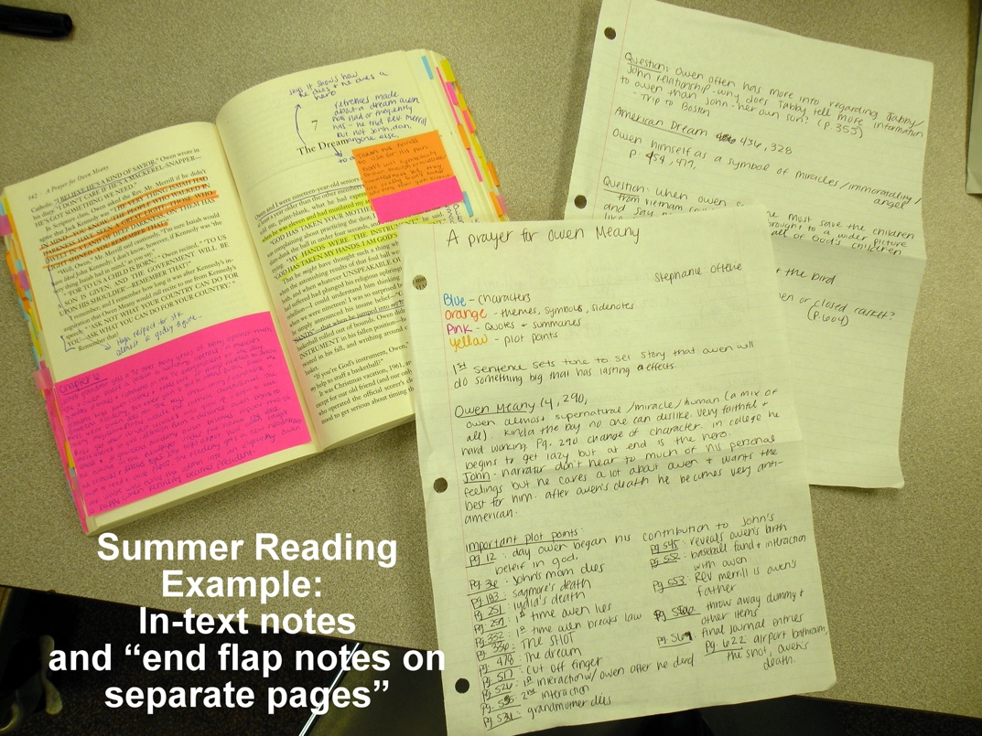
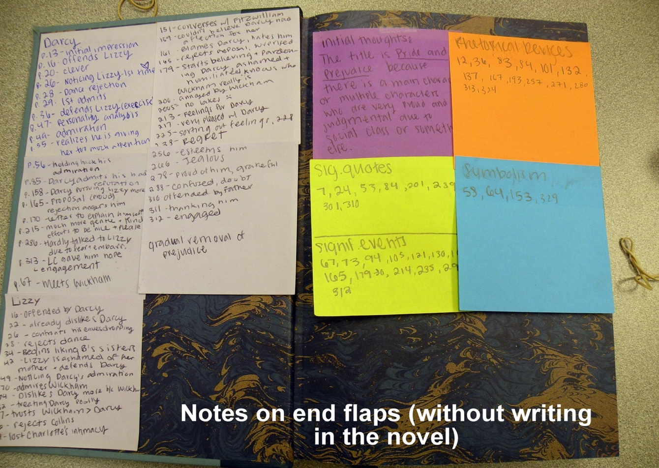

HERE ARE SOME REMINDERS

Highlight sparingly – coloring the entire reading does not help important information to stand out;

Cross reference – use end flaps to gather numerous page numbers with examples of the same technique or idea

Create individual coding systems that work for the reader

Remind oneself that active reading is a reader’s dialogue with the author;

Standardize where various kinds of notes appear (bottom right, top right, etc.) so that a reader can easily retrieve information of a certain kind, i.e., plot summaries are under chapter headings or references to a character’s personality are at the bottom right of pages or highlighted in yellow, etc.

Outlines, summaries, paraphrases are in the reader’s own words.

For more information on Active Reading, you may want to read Mortimer J. Adler’s essay “How To Mark A Book.” From The Saturday Review of Literature, July 6, 1940, pp. 11-12 Copyright 1940, The Sat. Review Co., Inc.; renewed 1967 Sat. Review, Inc.

RUBRIC--Evaluation for AP Lit & Comp SUMMER ACTIVE READING

Name ____________________________________________________________
2020 due date: Tuesday, September 1st, 2020
(regardless if your course runs first or second semester)
A Prayer for Owen Meany  by John Irving | SCORES | Pride & Prejudice  by Jane Austen | SCORES
In-text margin notes and marking: As you read, keep a record of the following—storyline, key events, characters, changes in character, key quotations, new/important vocabulary, symbols, imagery. Do this by highlighting, color coding, underlining, writing notes in margins, on bottoms, tops, or in corners of pages, and/or adding post it notes to accommodate your notes. etc. | Student self score:  _____/8  teacher score:  ____/8 | In-text margin notes and marking: As you read, keep a record of the following—storyline, key events, characters, changes in character, key quotations, new/important vocabulary, symbols, imagery. Do this by highlighting, color coding, underlining, writing notes in margins, on bottoms, tops, or in corners of pages, and/or adding post it notes to accommodate your notes. etc.  . | Student self score:  _____/8  teacher score:  ____/8
On end flaps or on separate sheets of paper: create titled lists of character names, symbols, significant quotations, motifs, themes, and vocabulary. Be sure to include page numbers on your lists. | Student self score:  _____/7  teacher score:  ____/7 | On end flaps or on separate sheets of paper: create titled lists of character names, symbols, significant quotations, motifs, themes, and vocabulary. Be sure to include page numbers on your lists | Student self score:  _____/7  teacher score:  ____/7
In-text personal commentary:  As you read, keep a record of the following—agree, disagree, compare or contrast to previous knowledge/ another book / ideas; write questions about what is not understood, predictions of what might happen “What if the character had done…?” | Student self score:  _____/5  teacher score:  ____/5 | In-text personal commentary:  As you read, keep a record of the following—agree, disagree, compare or contrast to previous knowledge/ another book / ideas; write questions about what is not understood, predictions of what might happen “What if the character had done…?” | Student self score:  _____/5  teacher score:  ____/5
____ /20 |  | ____ /20
RUBRIC--Evaluation for AP Lit & Comp SUMMER ACTIVE READING

Name ____________________________________________________________
2020 due date: Tuesday, September 1st, 2020
(regardless if your course runs first or second semester)
Tale of Two Cities by Charles Dickens | SCORES | Student comments:  In the space below, please comment on how your experience of “active reading” went, responses to the novels, or anything else regarding your summer reading assignment.  NOTE: These comments are required.
In-text margin notes and marking: As you read, keep a record of the following—storyline, key events, characters, changes in character, key quotations, new/important vocabulary, symbols, imagery. Do this by highlighting, color coding, underlining, writing notes in margins, on bottoms, tops, or in corners of pages, and/or adding post it notes to accommodate your notes. etc. | Student self score:  _____/8  teacher score:  ____/8 | Begin writing your student comments HERE:
On end flaps or on separate sheets of paper: create titled lists of character names, symbols, significant quotations, motifs, themes, and vocabulary. Be sure to include page numbers on your lists | Student self score:  _____/7  teacher score:  ____/7
In-text personal commentary:  As you read, keep a record of the following—agree, disagree, compare or contrast to previous knowledge/ another book / ideas; write questions about what is not understood, predictions of what might happen “What if the character had done…?” | Student self score:  _____/5  teacher score:  ____/5
 | ____/20

Do JOURNAL ENTRY WA#1: QUOTE PONDERING
2020 due date: Tuesday, September 1st, 2020
(regardless if your course runs first or second semester)
This journal entry must be at least two double-spaced typed pages (or two single-spaced pages of notebook paper). Do NOT put the traditional MLA heading at the top of your journal.
Your name, AP Lit, and the date is what you need to put on the top as well as the heading
“WA#1 Quote Pondering.” I highly recommend your typing your journals. Start a file for them
on your computer.

Because this is a course which relies heavily on your input and willingness to jump
into discussion, let's start with your personal reaction to one of the following quotations. Choose the
quote below that strikes/interests you most. Discuss what you think the quotation means literally, what
it might say about society, and what personal connections you might draw from your own experiences
with reading or in your own life. Finally, it is expected that you use any applicable/relevant examples
that come to mind from the three summer reading texts to exemplify the main points you are
making in your discussion. Before you start, be sure to read the suggested questions/ideas for
consideration listed further down below the quotes.

SIDE ONE: CHOOSE ONE OF THESE REQUIRED QUOTES:

QUOTE 1:
The whole point of literature is to have sympathies, imaginative relationships with people who are different from one’s self. --Irving Howe
FURTHER IDEAS TO PONDER WHEN WRITING ABOUT THIS QUOTE:
"The whole point"--really? What other points might there be? What books have touched you, made you feel empathy, changed you? Were they usually books assigned in school or those you read at home? What differences were there between you and the characters whose stories most affected you? Were the two of you, in retrospect, more alike than different?

QUOTE 2:
When Power leads man towards arrogance, literature reminds him of his limitations. When Power narrows the area of man’s concern, literature reminds him of his richness and diversity of existence. When Power corrupts, literature cleanses. --John F. Kennedy
FURTHER IDEAS TO PONDER WHEN WRITING ABOUT THIS QUOTE:
Why "arrogance"? why "corrupts"? why "cleanses"? what connotations/possibilities are there? Did the fact that Kennedy wrote this quote have any impact on you? Negatively? Positively?

QUOTE 3:
[ . . . ] the universe focuses those who live in it to understand it. Those creatures who find everyday experience a muddled jumble of events with no predictability, no regularity, are in grave peril. The universe belongs to those who, at least to some degree, have figured it out. --Carl Sagan
FURTHER IDEAS TO PONDER WHEN WRITING ABOUT THIS QUOTE:
The "universe"? why "creatures"? why "grave peril"? why "belongs"?

QUOTE 4:
On this day he (the Virginian) was bidding her farewell before undertaking the most important trust which Judge Henry had yet given him. For this journey she had provided him with Sir Walter Scott’s Kenilworth. Shakespeare he had returned to her. He had bought Shakespeare for himself. “As soon as I got used to readin’ it,” he had told her, “I knowed for certain that I liked readin’ for enjoyment.” --Owen Wister

FURTHER IDEAS TO PONDER WHEN WRITING ABOUT THIS QUOTE:
Why the incorrect grammar? How did that color impressions of him? Why did he buy Shakespeare? Enjoyment?

QUOTE 5:
Readers may be divided into four classes:
1. Sponges, who absorb all they read and return it nearly in the same state, only a little dirtied.
2. Sand-glasses, who retain nothing and are content to get through a book for the sake of getting through the time.
3. Strain-bags, who retain merely the drags of what they read.
4. Mogul diamonds, equally rare and valuable, who profit by what they read, and enable
others to profit by it also. --Samuel Taylor Coleridge

FURTHER IDEAS TO PONDER WHEN WRITING ABOUT THIS QUOTE:
Why "a little dirtied"? connotations of "strain-bags" and "drags"? Mogul diamonds? Why "mogul"?

SIDE TWO: YOUR ALL-TIME FAVORITE QUOTES
After you have completed your discussion on one of the required quotes, continue the journal with a a discussion of three of your all-time favorite quotes.
Jot down the first quote and then say something about why you chose this quote. Do this for each of the three quotes.
Expand your discussion of the quotes to make sure you have filled at least an entire page. Maybe you want to share why they are meaningful to you, how they apply to your life, and/or how you ran across them.
Underneath each quote say something about why you chose each one. Maybe you want to share why each one is meaningful to you, how each one applies to your life, and/or how you ran across them.

2020-2021 AP Lit. Short Answer Questions

NOTE: Completing these questions is required for all juniors registered for AP English 12: Literature & Composition. These questions will be an important sample and indicator of your writing preparedness for this AP class. Furthermore, you will receive points for completing this packet and the entrance essay.

If you would like to fill out this application electronically, find its WORD document on the AP website (see below for the URL). Be sure to print it out to turn in on the due date.

Name:

E-MAIL:____________________________ STUDENT CELL PHONE: ___________________________

COUNSELOR: ___ CONNECTIONS TEACHER: _________________________

PARENT/GUARDIAN CONTACT PHONE NUMBER _______________________________________

1. Please complete and return this packet or questions directly to Ms. Wallenberg in the English Resource Center in the English department on or before Tuesday, Sept. 1, 2020 regardless if your class is scheduled for first or second semester.

.
2. Summer reading of three novels, the annotation of these works, and the work associated with this reading is a course requirement. Turning in these three annotated novels and the work associated with the reading is also due in the English Resource Center in the English department on or before Tuesday, Sept. 1, 2020 regardless if your class is scheduled for first or second semester. A separate document outlines the novel titles as well as a description of the work associated with this reading and a rubric used to evaluate your work.

- Be sure to visit the AP Lit. website periodically throughout the summer and fall for
updates on the course.

Here is the URL for the AP WORDPRESS HOME PAGE:
https://wallenbergsplit1.wordpress.com/ (1st semester)
or
https://wallenbergsplit2.wordpress.com/2016/01/25/frankenstein-lesson-plans-and-hw-2013/ (2nd semester).

SHORT ANSWER QUESTIONS:
1. List all the English classes you have taken in grades 9-11, the instructors, and the grades you received in each course.

Gr. Level Course Title Instructor Final Grade
9 English 9 or Honors English 9 (circle which one.
10 English 10 or Honors English 10 (circle which one)
11 English 11 or Honors English 11 or AP Language & Comp 11 (circle which one)

(other English classes)

2. Which of your previous English courses did you find most valuable and why?

3. Why do you think you would be an excellent class member of AP Literature & Composition? Comment on your strengths as a writer and as a contributor to a discussion-based class and anything else of relevance.

4. Comment on your ability to resolve differences and disagreements in an academic setting. (For example, how do you handle criticism of your work?)

5. In all of the reading you have done during your high school years (either assigned as required reading or reading you have done on your own), which author and work has influenced you the most and why?

6. Read the article entitled “The Relationship of Reading and Writing” by Ann B. Dobie from her book Theory into Practice: An Introduction to Literary Criticism. This is a book we will be using periodically throughout our course. Annotate the article as you read—especially looking for your most significant points of interest. In the space provided below, discuss several “take-aways” from the article that strike you as being the most beneficial, illuminating, or concerning.

6. If you could make one change in your life, in school, or in society in general, what would it be? Be sure to explain the change, why you would make it, and what effect that change would have.

